



Team members:-

Aiswarya lakshmi.K Dharani.s Abinaya.M Brindha.G

Fathima rakshana.B

SYSTEM ARCHITECTURE

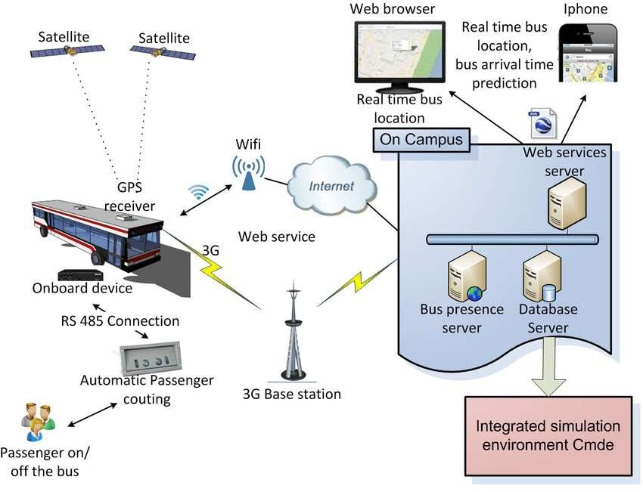

# SATELLITE:-

A satellite or artificial satellite is an object intentionally placed into orbit around a celestial body. Satellites have a variety of uses, including communication relay, weather forecasting, navigation, broadcasting, scientific research, and Earth observation.

# GPS:

There are five main uses of GPS: Location — Determining a position.

Navigation — Getting from one location to another. Tracking — Monitoring object or personal movement. Mapping — Creating maps of the world.

Timing — Making it possible to take precise time measurements

# ONBOARD DEVICE:-

Alternatively called integrated, onboard hardware is embedded into a circuit board. With a computer, onboard often refers to a device, like a sound card, network card, GPU (graphics processing unit), or WLAN (wireless local area network), integrated into the motherboard.

# RS-485 CONNECTIO:-

RS-485 is an industrial specification that defines the electrical interface and physical layer for point-to-point communication of electrical devices. The RS-485 standard allows for long cabling distances in electrically noisy environments and can support multiple devices on the same bus.

# Automatic passenger:-

the APC (Automatic Passenger Counting) systems, can be much more appropriate and of greater interest, as related to this short analysis. It is important to underline that – even though most of them are still at a development stage – the passenger counting technologies available on the market are various and the issues of different kinds; the combinations of technologies are such that no solution can be considered to date better than others or economically preferable a priori; every solution should be analysed in detail for applying it thereafter to the actual conditions of the public transport system or company.

# 3G BASE STATION:-

A fixed station that uses radio waves to communicate with mobile devices. It serves as the link between the user's device and the carrier's network. Base stations range in size and area of coverage.

WIFI:-

WIFI is a wireless networking technology that uses radio waves to provide wireless high-speed Internet access. A common misconception is that the term Wi-Fi is short for "wireless fidelity," however Wi-Fi is a trademarked phrase that refers to IEEE 802.11x standards.

# WEB BROWSER:-

A software application used to access information on the World Wide Web is

called a Web Browser.

A Web Service is an application that can be accessed over a network, such as the internet. A Web Server is a program that delivers content over HTTP. So, if you want your Web service to be accessed over the internet, you'll set it up on a Web Server.

# Presence Status Publication:-

The term presentity is used here to refer to a Presence Entity (a Presence Entity [presentity] is an entity, such as a person, who is defined by their ability and willingness to communicate). A presentity can publish a Presence Information Data Format (PIDF) document containing presence state to the Presence Server.

# What is a database server:-

A database server is a type of hardware that runs database software. Database software helps users or companies store, manage, retrieve, update or change files, information logs and other forms of digital data. The two primary components of database servers are back-end functions and client-facing services. The back end of a database server stores all the digital files and information. Client-facing services allow the people or companies using that database to access, modify, add to or moniter the data stored on server